(School District Name) Emergency Response Plan
For the
(School Name)

The purpose of this plan is to help the staff and students of _________________ Elementary/Middle/High School prepare to respond quickly, safely, and effectively to emergencies at school.

The plan will be reviewed, updated and approved annually.

Plan Approval: I have reviewed and approved the school emergency response plan.

Principal Date

Superintendent Date

School Board Chair Date

Plan Distribution list

Principal’s Office
School Secretary – Evacuation Go Kit
Superintendent’s Office
Transportation Director
Facilities Director
Local Emergency Management Director
Local Police Department
Local Fire Department
Local Ambulance Service
County Emergency Management Agency
County Sheriff’s Office

Emergency Plan Goal

To make every effort to provide for Student and Staff safety during an emergency event

Emergency Functions

- Emergency/Incident Management
- Communications
- Parental Notifications
- Student and Staff Accountability
- First Aid
- Public Information
- Relocation
- Reunification
- Facility Management
- Resource Management

Emergency Actions

- Lockout
- Lockdown
- Evacuate
- Shelter

Hazard Specific Actions

- Fire or Explosion
- Hazardous materials release
- Thunderstorm, Tornado or other unexpected high winds
- Disease Outbreak
- Bomb Threat or Suspicious Package
- Hostage Incident
- Active Killer/Shooter (firearms, explosives, knives, etc)
- School Bus Incident

A. Emergency/Incident Management

Emergency Management supports the incident through coordination, situational awareness and resource management. The District Superintendent will establish a District Emergency Operations Center (DEOC) to accomplish these tasks.

The DEOC will be located at
The DEOC phone number(s) are
The DEOC primary radio channel is
The DEOC radio channel link to the 911 Center is
The DEOC link to the County EMA’s online common operating picture is

Incident Command oversees the direction of the response at the scene of the incident. The School Principal will establish an Incident Command Post (ICP) to accomplish these tasks.

The ICP will be located at
The ICP phone number(s) are
The ICP primary radio channel is

District EOC Emergency Functions
- Emergency Manager
- Communications
- Public Information
- Parental Notifications
- Resource Management
- Relocation Transportation – District Assets
- Reunification

School Incident Command Emergency Functions
- Incident Command
- Communications
- Student and Staff Accountability
- Student and Staff Safety
- First Aid
- Resource Management – On-site personnel and equipment
- Relocation Transportation - On-site available buses
- Facility Management
District Emergency Operations Center

Function | Primary | Secondary
Emergency Manager  - Determine what is happening.  - Activate the District Emergency Operations Center.  - Recall the EOC staff. Delegate, if possible.  - Direct and monitor progress of EOC staff tasks.  - When timely, direct that support be given to students and staff for emotional and social recovery. | Superintendent | Asst. Superintendent
Communications  - Establish telephone or radio contact with the ICP.  - Activate the Parental Notification system to alert parents.  - Recall available staff from non-impacted schools to assist at the EOC, ICP and Reunification Site.  - Keep a record of events, actions, and communications. | Superintendent’s  Admin Asst. | Special Ed Director
Public Information Officer  - Send out an emergency press release to TV and Radio regarding the situation and what you want parents to do.  - Respond to calls from the Media.  - Establish a Media Center near the EOC, not the ICP. | Curriculum Director | IT Director
Resource Manager  - Determine what resources are needed at the incident and what their status is.  - Contact and reassign district/school resources as needed.  - Contact other districts/school and request resources. | Business Manager | Facility Director
Transportation Director  - Determine the location of the Incident Staging Area.  - Alert bus drivers and direct them to take their buses to the Incident Staging Area.  - Request additional busses from other School Districts.  - Coordinate with Law Enforcement to get buses through traffic control points and traffic.  - Request Law Enforcement monitor the Bus radio channel. | Transportation Director | Senior Bus Garage Mechanic
Reunification Site Manager  - Alert the Reunification Site facility owner of need for facility.  - Deploy to the Reunification Site with support staff.  - Set up signs for Parental Parking.  - Request several Law Enforcement officers to assist with parking/traffic control and with facility security.  - Locate rooms to be used for Locating Students, Locating Parents, and the Law Enforcement Interview Room.  - Acquire the Student Rosters.  - Activate the Student Release & Reunification procedures before turning students over to parents. | School Nurse | Human Resources Director

Incident Command Post

Function | Primary | Secondary
School Incident Commander  - Determine what is happening.  - Announce appropriate emergency actions (Lockout, Lockdown, Evacuate or Shelter)  - Activate the School Incident Command Post.  - Recall the ICP staff. Delegate if able.  - Direct the emergency response.  - Link up with the Public Safety Incident Commander.  - Provide all information as needed by Public Safety.  - As conditions change, inform the classrooms on the current situation.  - Review Accountability Status.  - Request additional resources, especially personnel. | Principal | Senior Teacher
Communications  - Call 911. After initial report, do not hang up phone!  - Establish telephone or radio contact with the EOC. Consider leaving that line open as well.  - Recall available non-classroom staff to the ICP.  - Keep the EOC up to date with incident information. Report all school resource requests to the EOC. | Principal’s Admin Assistant | Ed Tech
Accountability Leader (Students and Staff)  - Collect accountability reports from all Classroom Teachers.  - Coordinate immediate area searches for those missing. | Guidance Counselor | Special Ed Teacher
Classroom Teachers (Safety)  - Complete all appropriate emergency actions (Lockout, Lockdown, Evacuate or Shelter). Use your classroom emergency response guide.  - Account for all students. Report to Accountability Leader.  - Follow all directions of Incident Command through the Accountability Leader or over the PA system.  - Supervise students in carrying out emergency procedures.  - Seek help to assist with those with special needs. | Classroom Teacher | Ed Techs
First Aid (When safe to do so)  - Provide first aid to the injured.  - Recruit unassigned personnel to assist.  - Account for and record location of the injured and dead not located in classrooms.  - Coordinate with EMS when they arrive. | School Nurse | Kitchen Manager
Resources  - Determine what resources are needed at the incident and what their status is.  - Request Communication contact the EOC for additional resources that are needed.  - Supervise transportation and facility personnel.  - Direct all off-site evacuations. | Title III Teacher | Social Worker/ Art/ Music or Phys Ed
Transportation  - Locate all on-site buses and drivers and move them to a Staging Area.  - Coordinate with on-site Police or Fire for movement of school buses should an evacuation be directed. | Available Bus Driver | Next Available Bus Driver
Facilities  - Ensure that entrances are locked, as appropriate for the Emergency Actions director by Command.  - Ensure that nobody is left behind in building.  - Shut off utilities, as directed. | Custodian | Food Service Staff member

B. Communications

The methods for communicating will be as follows:

From | To | Primary Method | Secondary Method
School ICP | Classrooms | PA System | Text/E-Mail
Classrooms | School ICP | Text/E-Mail | Telephone
School ICP | District EOC | Telephone | Radio
School ICP | 911 Center | Telephone | Radio
School IC | Responder IC | Radio | Cell Phone

These areas at the school cannot be reached by the public address/bell system
In an emergency, they will be alerted as follows

School Contact Information | Name | Phone #
Principal’s Office
Principal
District Main Office
Superintendent
Assistant Superintendent
District Facilities Office
Facility Director
District Transportation Office
Transportation Director
Business Manager
Information Technology
Commercial towing service

Public Safety
Police, Fire, EMS |  | 911
County Emergency Management Office |  | 338-3870 or 911
Maine Poison Control Center |  | 800-442-6305 / 800-222-1222
Waldo County General Hospital |  | 338-2500 / 800-649-2536
Maine Center for Disease Control |  | 800-821-5821 (24 hours a day)
National Suicide Prevention Lifeline |  | 800-273-TALK (800-273-8255)
Child Protective Services |  | 1-800-432-7802
Victim Assistance office |  | 338-2512
Sexual Assault Support Services/Midcoast |  | 1-800-822-5999
Utilities
Central Maine Power | 800-696-1000
Water
Sewer
Public Works
Security
Phone Company
Media
TV
Radio
Newspaper
Social Media

Radio Communications
Between |  | Radio Channel | Repeater or Simplex
School ICP | District EOC | ? | ?
Classrooms | School ICP | FRS 1 | Simplex
School ICP | 911 Center | Fire North or South | Voter Repeater
School IC | Responder IC | State Fire | Simplex
School ICP | School Buses | Transportation | Transportation
School 1 | School 2 | Transportation | Transportation

Radio User | Type of Radio | Channels Programmed
District EOC  (Superintendent’s Office) | 2-way base VHF radio | 1) School Transportation  2) Fire North or South  3) County EMA
School ICP (Principal’s Office) | 2-way base VHF radio and 2-3 Dual band handheld radios | 1) School Transportation  2) Fire North or South  3) FRS 1  4) Town FD  5) Waldo Tac1
School Buses | 2-way mobile VHF radio | 1) School Transportation  2) Fire North or South  3) Waldo Tac1
Classroom Teachers | FRS UHF Radio | 1) FRS channels

C. Parental Notification

The school has the following avenues for communicating with families regarding the emergency:

System/Method | Assigned Position | Description
Phone tree
Mass Phone Notifying System
E-Mail
Texting
Website
Social Media

Procedures for activating a mass notification of parents:

School contact information

Staff Member Name | Phone Number | Emergency Contact | Emergency-related skills  (first aid, firefighting, search and rescue, counseling, or negotiation)

D. Student and Staff Accountability

These steps will be followed during a lockdown, lockout, shelter or evacuation or whenever directed by the School Incident Commander.

  - Teachers who are with students when an emergency begins, stay with them until it is resolved.
  - Take attendance at the start of the emergency and every time you and your students move to a new location.
  - Provide your accountability report to the Accountability Manager initially and whenever there has been major movement or changes.
  - Report missing, extra, and injured students to the Accountability Manager, who will compile them, ascertain whether anyone is missing, and notify the School Incident Commander.

E. First Aid

All staff, students and visitors are authorized and encouraged to perform basic first aid and stop-the-bleed techniques to those who have been injured on the school premises or bus. First Aid responders should scan the area for hazards and look for medical alert tags. Practice proper bloodborne pathogen exposure control. Use disposable gloves if available. Wash hands after providing care.

The School Nurse shall be contacted immediately for all medical incidents, major or minor.

Emergency services (911) shall be contacted for all medical emergencies. Then contact the main office. (Do this simultaneously if people are available).

F. Public information

When speaking with members of the media or the public, do not speculate, guess, cast blame, make promises you’re not sure you can keep, say “no comment,” comment “off the record,” try to predict the future, or lose your temper.

You don’t have to be superhuman or please everyone. Just be accurate, and as helpful as you can be within reasonable limits. Don’t be afraid to say “I don’t know, but I’ll get back to you.”

Public information is handled at the ___ school ___ district level.

The person designated to speak with the media on behalf of the school is __________.

Backup/alternate: ______________________________.

All others are encouraged to refer media questions to this spokesperson.

The work area for the school’s public information staff will be ____________________.

The media staging area will be ______________________________.

The media can help the school get crucial information out to families and the community. If we treat media representatives with courtesy and generosity, we are more likely to be able to set limits when we need to.

Media contact information is listed in the “Emergency information” section of this plan.

When working with the media:

- Issue a simple, factual statement as soon as possible after the incident.
- Designate an area for media representatives to gather that is convenient for them but not too close to the active response or to the families’ waiting area.
- Provide a space for the district’s public information staff to work, with phone and Internet connection and enough room to accommodate PIOs from other agencies if necessary.
- For interviews, choose a site that protects student and staff privacy and is free of distressing background sights and sounds.
- Look for ways that media representatives can get meaningful photographs and video footage without compromising privacy or hindering emergency responders. If necessary, consider “pool” coverage, where one still photographer and one video photographer are given access and share their work with colleagues.
- Keep a record of actions taken, including copies of any documents produced.
- Further guidelines for working with the media are included in the “Forms, templates, and job aids” section.
- If there is an evacuation, media announcements should include the request that parents bring identification when they come to pick up their children.

G. Relocation

1. The School Incident Commander shall immediately notify the Superintendent’s Office to request emergency transportation of students and staff to the offsite relocation site. If contact cannot be made with the Superintendent’s Office, attempt to reach the Transportation Director, directly.

2. Transportation will not be needed to evacuate to the On-Site Relocation Site; however, buses will be requested to provide overflow capability and in case an evacuation to the offsite location becomes necessary.

The On-Site Relocation Site is
The Off-Site Relocation Site is
Alternate Off-Site Relocation

3. If buses are not available or drivers cannot be contacted, contact the nearest school district and request mutual aid bus transportation.

4. The Relocation Site may end up being the Reunification Site also, but this will be dependent on the situation. Once all the students have been accounted for, the students may be relocated to a Reunification Site, if the Relocation Site is not appropriate, due to safety issues or inadequate parking spaces.

5. Radio or phone communications will be maintained at all times between the school buses, School Incident Commander, District EOC and Reunification Site Manager.

6. Inform 911 of the location of the Relocation Site.

7. The Reunification Site Manager is responsible for setting up the Reunification Site; hopefully before the affected school staff and students arrive. The Reunification Site Manager will work closely with the School Accountability Leader when they arrive at the Reunification Site.

H. Reunification

1. The District Reunification Site Manager with assistants will be selected by the District EOC Emergency Manager and will report to the chosen Reunification Site. The Reunification Site Manager will oversee all operation at the Relocation Site and will be in contact with the District EOC.

The Reunification Site is

2. The Reunification Site Manager will have the following supplies to establish the Reunification Site.

position vests | student release forms | megaphone
signage | clipboards | laptop computer
2-way radio | pens | copies of floor plans
cell phone | masking tape

3. The School Accountability Manager is responsible for bringing the cards to the Reunification Site. This Manager will establish a Student Check-in Table and Student Assembly Area.

4. The classroom teachers will stay with their students in the secure Student Assembly Area at the Reunification Site.

5. The Reunification Site Manager will utilize available school staff (Ed techs, bus drivers, admin staff, etc.) and assign the following positions:

- Parent Check-In Clerks
- Student Release Form or Reunification Form Greeter
- Parent Reunification Area Clerk

6. The School Accountability Manager will notify the Reunification Site Manager if there is/are a missing student(s). This will be relayed to the District EOC, Law Enforcement and the Parent Check-In Clerks.

7. Parents will fill out the Student Release Form or Reunification Form and present a picture ID.

8. The name on the form will be matched to the ID card and to the authorized names on the emergency care card. If the names match, send the Parent to the Parent Reunification Area. If the names don’t match, the student will not be released under any circumstances unless personally authorized by the Reunification Site Manager, in consultation with the District EOC.

9. The Student Assembly Area will be well separated from the Parent Check-In Area.

10. The Parent Reunification Area Clerk will serve as a runner between the Student Assembly Area and the Parent Reunification Area.

11. The Parent Reunification Area Clerk will escort the students from the Student Assembly Area to the Parent Reunification Area.

12. Students not picked up by parents or guardians will be transported by bus and dropped off at their designated bus stop only after parents have been notified about the arrangement.

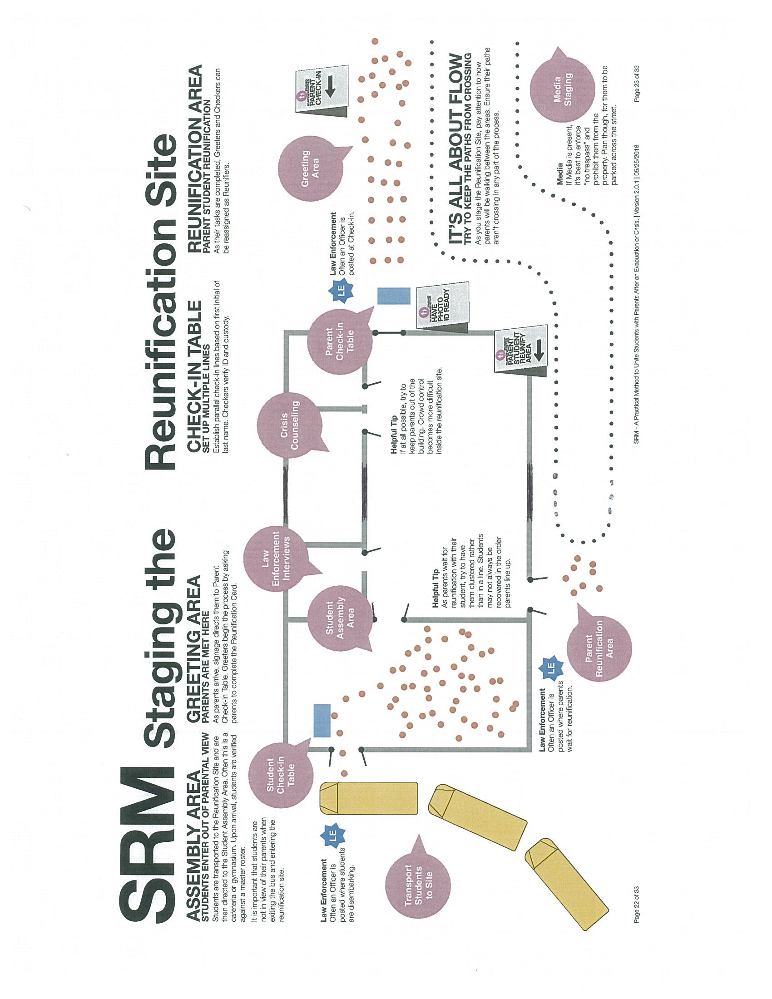
I. Facility Management

1. School overview: This school serves grades ______ through ________.

Grade | # of Students
Total
# of Teachers
# of other staff
# of students with special needs
Special needs information is kept here
Hazardous materials locations
Fire Dept Connections Locations
Electrical Shutoff Locations
Water Shutoff Locations

2. School maps (Insert as many maps as you have available)

- Building floor plans

Note room numbers, exits and entrances (show which way doors open), stairs and elevators, fire alarms, and hazardous materials. Include utility shutoffs (water, electric, sprinkler, ventilation/air conditioning), and fire alarm shutoff.

- Site map
  - Include fire hydrants and hazardous materials locations.
  - Note evacuation routes and bus staging area.
  - Note tentative locations for command post, medical triage and treatment area, public information office, staging areas for first responders, media, and parents, and where to set roadblocks for traffic control.
  - May be an aerial photo of school and surroundings

Building Floor Plan
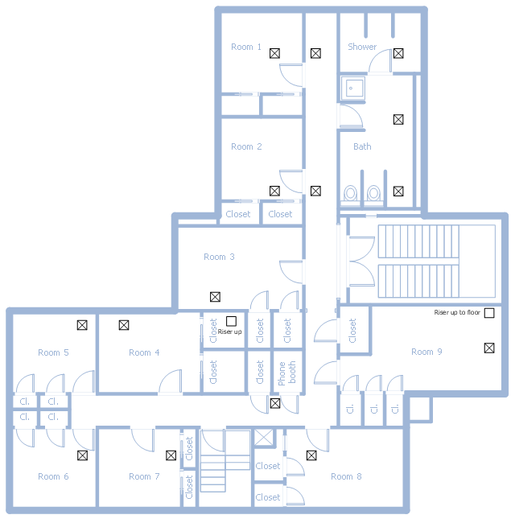

Site Map
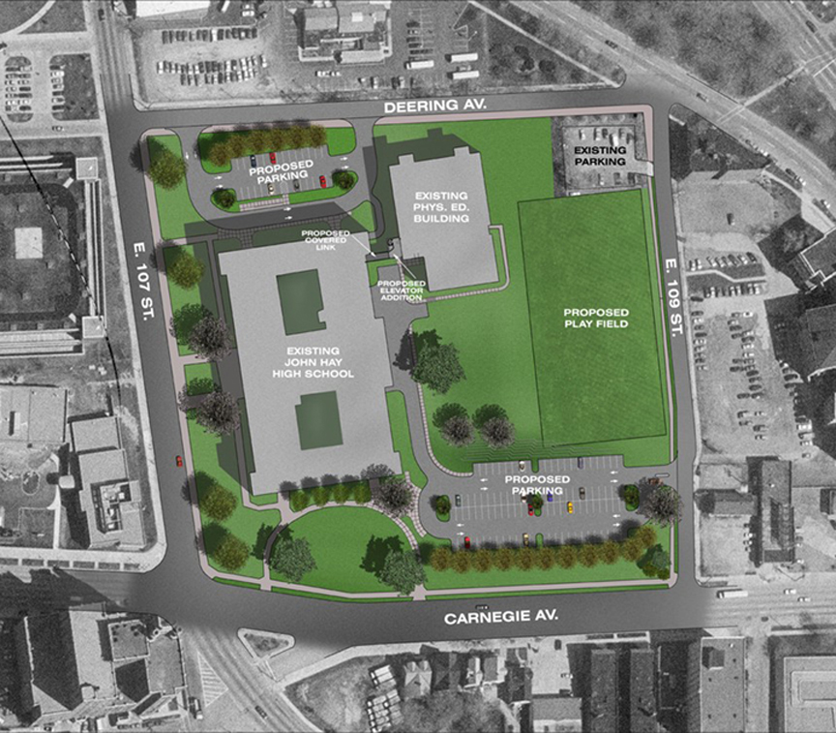
J. Resource Management

Emergency Resources | Where to acquire
School Buses
School Nurses
Mental Health
Reunification Staff
Backup Communications | - County Incident Management Team  - Radio Vendor – list
Alternate Reunification Sites
HazMat Cleanup Vendor
First Aid Supplies
Backup Power Generation
List out all the resources you might need during an emergency

Emergency Items | Classroom | Main office | School Bus
First Aid Kit | X | X | X
Flashlight w/extra batteries | X | X | X
Duct Tape | X | X | X
Gloves, disposable | X | X | X
2-way radio | X | X | X
AM/FM Radio and/or Weather Alert Radio |  | X | X
Whistles | X | X | X
Classroom Emergency Response Guide | X | X
Laptop Computer |  | X
Paper and pencils | X | X | X
Site maps and floor plans |  | X
Staff Roster – with room, phone numbers |  | X
Student Roster, registered |  | X
Student Roster, current day | X | X | X
Emergency care cards |  | X
Special needs list |  | X
Student photos |  | X
Student Release Forms |  | X
Hand sanitizer and sanitizing wipes | X | X | X
Space Blanket | X |  | X
List out the emergency items you will need in your school and buses.

Hazard Specific Actions
Hazard | Emergency Action | Emergency Functions
Bomb Threat | Evacuate | Emergency/Incident Mgmt  Communications  Student & Staff Accountability  Public Information  Parental Notifications  Relocation Transportation  Reunification  Resource Management
Suspicious Substance | Shelter | Emergency/Incident Mgmt  Communications  Student & Staff Accountability  Public Information  Parental Notifications  Facility Management  Resource Management
Fire | Evacuate | Emergency/Incident Mgmt  Communications  Student & Staff Accountability  Public Information  Parental Notifications  Relocation Transportation  Reunification  Facility Management  Resource Management
Explosion | Evacuate | Emergency/Incident Mgmt  Communications  Student & Staff Accountability  First Aid  Public Information  Parental Notifications  Relocation Transportation  Reunification  Facility Management  Resource Management
Hazardous Materials Release (Inside) | Evacuate | Emergency/Incident Mgmt  Communications  Student & Staff Accountability  First Aid  Public Information  Parental Notifications  Relocation Transportation  Reunification  Facility Management  Resource Management

Hazard | Emergency Action | Emergency Functions
Hazardous Materials Release (Outside) | Shelter | Emergency/Incident Mgmt  Communications  Student & Staff Accountability  Public Information  Parental Notifications  Facility Management  Resource Management
Disease Outbreak | Release Students | Emergency/Incident Mgmt  Communications  Student & Staff Accountability  First Aid  Public Information  Parental Notifications  Early Transportation  Resource Management
Hostile Threat  (Outside) | Lockout | Emergency/Incident Mgmt  Communications  Student & Staff Accountability  Public Information  Parental Notifications  Facility Management  Resource Management
Hostile Threat (Inside) with casualties | Lockdown &  Evacuation | Emergency/Incident Mgmt  Communications  Student & Staff Accountability  First Aid  Public Information  Parental Notifications  Relocation Transportation  Reunification  Facility Management  Resource Management
Severe Weather – surprise onset. | Shelter | Emergency/Incident Mgmt  Communications  Student & Staff Accountability  Parental Notifications  Facility Management
School Bus Incident | Follow the emergency actions depending on the type of incident. | Emergency/Incident Mgmt  Communications  Student & Staff Accountability  First Aid  Public Information  Parental Notifications  Relocation Transportation  Reunification  Resource Management
Attach Specific Emergency Policies
1. Lockout
Lockout is called when there is a threat or hazard outside of the school building.
Lockout uses the security of the physical facility to act as protection.
Lockout is similar to a lockdown but allows classroom activities to continue.

The alert for lockout is “Lockout! Secure the Perimeter” repeated twice.

The all-clear signal is ______________________________ and the School Incident Commander is authorized to announce it.

Function
School Incident Commander
- Announce the emergency action of “Lockout”.
- Establish an Incident Command Post.
- Notify 911 and the Superintendent that the school is in Lockout.
- Ensure that all students and staff are in their classrooms.
- Evacuate temporary buildings/portables to the main building.
- Bring all students and staff who are outside back into the building.
- Cancel all outside activities.
- Determine if anyone can be released outside (end of school, trips, student appointments, etc)
- Notify the Superintendent when all Lockdown activities have been completed.
Communications
- Call 911. Report that the school is in Lockout.
- Establish telephone or radio contact with the EOC.
- Hold all bells from being sounded.
- Request that District notify parents that the school is in Lockout.
Accountability Leader (Students and Staff)
- Collect accountability reports from all Classroom Teachers.
- Coordinate immediate area searches for those missing.
Classroom Teachers (Safety)
- Complete all appropriate emergency actions for Lockout.
- Ensure that all windows and exterior doors in classrooms are locked
- Account for all students. Report to Accountability Leader.
- Follow all directions of Incident Command through the Accountability Leader.
- Supervise students in carrying out emergency procedures.
- Seek help to assist with those with special needs.
- Continue all inside classroom activities.
Facilities
- Double check and ensure that all doors and windows in the school are locked.

2. Lockdown
Lockdown is called when there is a threat or hazard inside the school building.
Lockdown uses classroom security to protect students and staff from threat.

The alert for a lockdown is “Lockdown! Locks, Lights, Out of Sight!” repeated twice.

The all-clear signal is ______________________________ and the School Incident Commander is authorized to announce it.

Function
School Incident Commander
- Announce the emergency action of “Lockdown”.
- Establish an Incident Command Post.
- Notify the Superintendent that the school is in Lockdown.
- Monitor the situation with security cameras if available.
- Inform the staff and students of current situation, as able.
- Do not lock outside doors or other access points. Leave the perimeter as is.
- Update the Superintendent as able. Use the Communications Officer to make calls.
- Link up with the Public Safety Incident Commander and provide situation report.
Communications
- Call 911. Report that the school is in Lockdown.
- Establish telephone or radio contact with the District EOC.
- Hold all bells from being sounded.
- Request that District notify parents that the school is in Lockdown.
Accountability Leader (Students and Staff)
- Collect accountability reports from all Classroom Teachers.
- Coordinate immediate area searches for those missing.
Classroom Teachers (Safety)
- Lock all classroom doors or other access points.
- Cover door window if able.
- Move room occupants out of line of sight of the corridor windows.
- Order all room occupants to maintain absolute silence. Order cell phones to be silenced.
- Do not open the classroom door for any reason.
- Account for all students. Report to Accountability Leader if able by texting, email or other silent method.
- Follow all directions of Incident Command.
- Supervise students in carrying out emergency procedures, such as first aid.
- Seek help from those present to assist with those with special needs.
- If you believe that it is too dangerous to stay in the classroom, order the classroom to evacuate through a window to the outside.
- TEACHERS MUST STAY CALM AND MAKE DECISIONS. Do what you have to do to save the students in your care. Counter the threat, if necessary and able.

For those outside the building, they will need to use their judgement as to whether they can more quickly reach a safe place on campus or off campus. Once they have reached safety, if there is a safe way to let authorities know their location, they should do so.

3. Evacuate
Evacuate is called when there is a need to move students from one location to another.

The alert for an Evacuation is “Evacuate! (Directions to Follow)” repeated twice.

- For a Fire, use the Fire Alarm.
- For a Bomb Threat, choose an evacuation site with as much distance and shielding (e.g., sturdy wall or earthen bank) from the suspected bomb as possible.
- For a Hazardous Materials spill, choose a site at least 300 feet away.
- Anyone who realizes that a dangerous situation exists outdoors, should announce an Evacuation back into the school facility.

Function
School Incident Commander
- Determine if it is safe to evacuate.
- Announce the emergency action of “Evacuate”.
- Establish a Field Incident Command Post.
- Ensure that evacuation supplies/materials/kits are taken.
- Follow the Relocation and Reunification procedures.
Communications
- Call 911. Report that the school is being evacuated.
- Notify the Superintendent. Establish telephone or radio contact with the District EOC.
- Recall available non-classroom staff to the Field ICP.
- Request the District notify parents of the Reunification Site.
Accountability Leader (Students and Staff)
- Collect accountability reports from all Classroom Teachers.
- Coordinate immediate area searches for those missing.
Classroom Teachers (Safety)
- Complete all appropriate emergency actions for Evacuation.
- Account for all students. Report to Accountability Leader.
- Follow all directions of Incident Command.
- Supervise students in carrying out emergency procedures, such as first aid.
- Seek help to assist with those with special needs.
First Aid (When safe to do so)
- Provide first aid to the injured.
- Recruit unassigned personnel to assist.
Resources
- Supervise transportation and facility personnel.
- Direct all off-site evacuations.
- Notify the Relocation Site and Reunification Site point of contact.
Transportation
- Organize all buses and drivers and move them to a Staging Area.
- Coordinate with Incident Command for movement of buses should an evacuation be directed.
Facilities
- Ensure that nobody is left behind in building.
- Shut off utilities, as directed.

4. Shelter
Shelter is called when the need for personal protection is necessary.

The alert for sheltering in place is “Shelter! (Directions to Follow)” repeated twice.

The all-clear signal is _____________________________.

The best locations to shelter are those without exterior doors and windows, or as few as possible. If the hazard is an outside hazardous materials release, moving to floors above the ground floor is best. If the threat is a tornado, moving to a basement location is best, with an interior hallway being next best.

Function
School Incident Commander
- Determine where the students need to shelter (i.e. hallways, basements, etc.)
- Announce the emergency action of “Shelter”.
- Establish an Incident Command Post.
- Ensure that all students and staff are in their shelter locations.
- Update the Superintendent on the Situation.
- Request the District notify parents and the public to stay away from the school.
- If time, evacuate temporary buildings/portables to the main building.
- Cancel outside activities.
- Monitor the emergency by radio, Internet, and/or other means.
Communications
- Call 911. Report that the school is Sheltering.
- Establish telephone or radio contact with the EOC.
- Hold all bells from being sounded.
Accountability Leader (Students and Staff)
- Collect accountability reports from all Classroom Teachers.
- Coordinate immediate area searches for those missing.
Classroom Teachers (Safety)
- Follow the directions provided by the School Incident Commander.
- Stay away from all exterior doors and windows.
- Account for all students. Report to Accountability Leader.
- Supervise students in carrying out emergency procedures, such as first aid.
- Seek help to assist with those with special needs.
- Keep the students occupied.
Facilities
- Ensure that the HVAC system is shut down completely.
- Ensure that all doors and windows in the school are closed.

Addressing Special Needs

During an emergency, repeat messages frequently and in the simplest possible terms. This will help everyone. Provide messages in alternate formats as needed.

As of this date (______), this school has students, staff or regular visitors known to have
____ yes ____ no impaired mobility
____ yes ____ no impaired vision
____ yes ____ no impaired hearing
____ yes ____ no cognitive disabilities
____ yes ____ no medication that needs to be taken during the school day
____ yes ____ no medication that needs to be refrigerated
____ yes ____ no an assistive device that requires electricity
____ yes ____ no a condition that could become unmanageable under stress of
____ yes ____ no other special needs: _____________________________.

If “yes” was checked above, specific information about who may need help with these needs during an emergency is kept _____________________________.

Helping people with special needs during an evacuation

People’s needs and preferences will vary, whether they are adults or children. Ask before you try to help.

If smoke or vapors are present, help anyone with respiratory complications immediately.
Remind people with medications to bring them when they evacuate.

For visually impaired individuals:
  - Announce the type of emergency.
  - Offer your arm for guidance.
  - Tell the person where you are going, and describe any obstacles you encounter.
  - When you reach safety, ask if further help is needed.
For hearing-impaired individuals:
  - Use gestures or turn lights on and off to gain the person’s attention.
  - Write a note with evacuation directions, or use gestures.
  - Make sure further instructions, for example at the relocation site, are understood.
For individuals using crutches, canes or walkers:
  - If necessary, give the same support you would give to an injured person.
  - Help them walk to the evacuation site, if possible.
  - If necessary, carry them to safety. You may be able to seat them in a sturdy chair, or one with wheels, and carry or push it.
For individuals using wheelchairs:
  - Most wheelchairs are too heavy to carry; if the chair can’t be pushed to safety, consult with the person to determine the best carry options.
  - Reunite the person with the wheelchair as soon as possible.

Emergencies on the Bus

Our buses are equipped with the following communications equipment: ____________.

Bus drivers and bus chaperones are informed about all medical conditions, allergies, and other special needs of students traveling by bus as follows:
    - Routine bus routes: ________________________________.
    - Field trips and special events: ________________________________.

Our procedure for calling in bus drivers outside of normal working hours is: _________.

During off-campus emergencies, as soon as it is safe to do so, the driver/adult supervisor should contact 911 and the Superintendent.

School Bus Accident

If able, the bus driver will take charge of the incident and other adults present will assist.

- Treat every accident seriously, no matter how minor.
- Stop, turn on flashers, turn off the ignition, take the keys from the ignition, and investigate.
- Keep students on the bus unless it is in danger. (If it is stopped on a hill or curve, oncoming traffic must be able to see it for at least 300 feet.)
- If you must evacuate the bus:
  - Tell passengers what exits to use and where to reassemble.
  - If you suspect a passenger may have a head, neck, or back injury, do not move him/her unless absolutely necessary, and then use extreme caution.
  - Take first aid kit and passenger roster and put bus radio microphone out through the window.
  - Make sure all passengers have left the bus.
  - Make sure students are supervised at the assembly point.
- Talk with students calmly and tell them what is happening.
- Set out flares if needed. Recommended: one 100 to 300 feet in front of the bus on the shoulder occupied by the bus, one 100 to 300 feet behind the bus on the shoulder occupied by the bus, and one 10 feet behind the bus.
- Assign someone to direct traffic if there is a hazard.
- Prohibit smoking near the accident.
- Flag oncoming traffic for help if needed.
- Check for fire.
  - Evacuate students to a place well off the road and 100 yards from the bus.
  - Take the emergency kit with you.
  - Take attendance and determine if there are any missing students.
- Check students for injuries. If there are injuries:
  - Call 911.
  - Perform first aid, within the scope of your training, in this order of priority: restore breathing, stop severe bleeding, treat shock, treat minor injuries. Protect yourself from contact with body fluids; use gloves and goggles if at all possible.
  - If students must be taken to hospital, send a teacher or chaperone to accompany them.
  - Call the school, giving detailed information about any passengers injured or sent to hospital.
    - Record names and contact information for witnesses, license numbers of vehicles involved, make and year of vehicles, and insurance information.
    - Document if applicable: road markings; resting location of vehicles, victims, and debris; damages, and injuries.
    - Do not speak to anyone about the accident except law enforcement and school officials.
    - Do not let the vehicles be towed away until the investigation is complete.
    - Do not leave the scene until you have been excused by law enforcement and school officials.
    - Keep a log of all important actions and incidents with times.

Superintendent’s Office

- Notify parents or guardians of the incident. Inform them to pick up their children at the school, not from the bus.
- Deploy additional staffing assistance to the impacted Bus.
- Deploy another school bus to pick up the students and bring them back to their school.
- Deploy the school nurse(s) to the school to assess the condition of the students.
- Set up and perform a Parent-Student reunification process at the school.
- Release student(s) to parent or guardian.
- Work with bus driver to complete a written record of the incident, including time and location of accident, description of accident, bus driver’s name, vehicle, number of passengers, number of injured, actions taken, and any other relevant details.
- Get copies of other agencies’ reports.

Intruder on the bus
- If anyone unauthorized attempts to board the bus, call 911.
- Notify the Bus Garage and/or Superintendent.
- If the intruder succeeds in boarding the bus, remain calm. If he/she is armed, ask for permission for the students to leave the bus.

